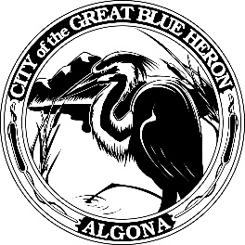 | City Council Regular Meeting
 | Monday, October 16, 2023 at 7:00 PM
 | City Hall
 | Agenda
1. Call to Order
2. Flag Salute
3. Roll Call
4. Presentation
5. Approval of Agenda
6. Consent Agenda
A. Minutes
September 25th, 2023 Council Meeting
B. Audit of Reports
1. Claims #113193 - #113234 = $235,241.01
October 16, 2023
2. Payroll #61567 - #61570 = $173,659.41
September 29, 2023 & October 13, 2023
VOID
7. Reports
8. Audience Participation
The City Council encourages public participation during meetings of the City Council and welcomes your comments. This time is set-aside for you to speak to the City Council on any issue. The Council ordinarily takes non-agenda matters under advisement before taking action. You are also invited to comment on action items as they are considered during the meeting. Individual speakers will be limited to three (3) minutes each in addressing the City Council. When addressing the Council, please speak clearly and audibly and state your name and address for the record.
9. Discussion
A. 2024 Preliminary Budget
B. Wetland Preserve Final Design Scope of Work with Natural Systems Design
C. King County Re+ Grant Agreement
D. Resolution 1264-23, King County External Support Grant for Sound Garden
E. Resolution 1265-23, Surplus of Public Works Assets
F. Purchase and Sale Agreement
G. Right of Way Vacation for the Algona Village Project
10. New Business
11. Old Business
12. Ordinances & Resolution
A. Resolution 1262-23, Waste Management New Rate Structure
13. Next Workshop
14. Adjournment

