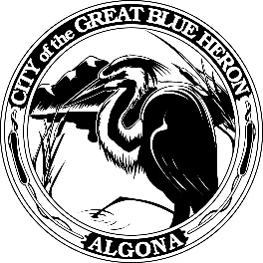 | City Council Regular Meeting
 | Monday, December 11, 2023 at 7:00 PM
 | City Hall
 | Agenda
1. Call to Order
2. Flag Salute
3. Roll Call
4. Presentation
5. Approval of Agenda
6. Consent Agenda
A. Minutes
November 27th, 2023 Council Workshop
November 27th, 2023 Council Meeting
B. Audit of Reports
1. Claims #113319 - #113363 = $507,259.70
December 11, 2023
2. Payroll = $ 74,593.66
December 8, 2023
VOID
7. Reports
8. Audience Participation
The City Council encourages public participation during meetings of the City Council and welcomes your comments. This time is set-aside for you to speak to the City Council on any issue. The Council ordinarily takes non-agenda matters under advisement before taking action. You are also invited to comment on action items as they are considered during the meeting. Individual speakers will be limited to three (3) minutes each in addressing the City Council. When addressing the Council, please speak clearly and audibly and state your name and address for the record.
9. Discussion
A. Resolution 1268-23, Franchise Fee
B. Department of Commerce, Local and Community Projects Grant Agreement
10. New Business
A. City Clerk Contract
B. Scheduling Second Council Meeting in December 2023
11. Old Business
A. 2024 Olympic Environmental Resources Agreement
B. Algona Police Officers Contract Memorandum of Understanding
C. WA Department of Commerce Middle Housing Grant Agreement
12. Ordinances & Resolution
A. Ordinance 1230-23, 2023 Budget Amendment
B. Ordinance 1231-23, 2024 Final Budget
C. Resolution 1267-23, WaFed Bank
D. Ordinance 1227-23, 2024 Water Rate
E. Ordinance 1228-23, Sewer Rate Increase for 2024
13. Next Workshop
14. Adjournment

