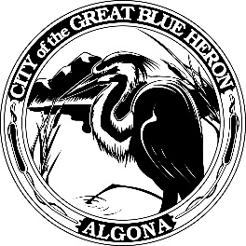 | City Council Regular Meeting
 | Monday, January 08, 2024 at 7:00 PM
 | City Hall
 | Agenda
1. Call to Order
2. Flag Salute
3. Roll Call
4. Presentation
A. Life-Saving Award - Officer Dubois and Corporal Phan
B. Oath of Office - City Clerk Dana Parker
C. Oath of Office - Mayor Troy Linnell, Council Member Timothy Fairley, Council Member David White, and Council Member William Thomas
D. Appointment and Oath of Office - Planning Commission Member Jennifer Freeberg
5. Approval of Agenda
6. Consent Agenda
A. Minutes
December 11th. 2023 Council Workshop
December 11th, 2023 Council Meeting
December 18th, 2023 Special Council Meeting
December 28th, 2023 Special Council Meeting
B. Audit of Reports
1. Claims #113364 - #113366 = $ 24,895.32
December 31, 2023
2. Claims #113367 - #113422 = $394,729.58
January 8, 2024
2. Payroll # = $ 79,470.01
January 5, 2024
VOID #
7. Reports
8. Audience Participation
The City Council encourages public participation during meetings of the City Council and welcomes your comments. This time is set-aside for you to speak to the City Council on any issue. The Council ordinarily takes non-agenda matters under advisement before taking action. You are also invited to comment on action items as they are considered during the meeting. Individual speakers will be limited to three (3) minutes each in addressing the City Council. When addressing the Council, please speak clearly and audibly and state your name and address for the record.
9. Discussion
A. Department of Commerce, Local and Community Projects Grant Agreement
B. Transportation Improvement Board Grant Agreement
C. EJ Municipal Land Use Planning Agreement
10. New Business
A. Mayor Pro Tem Appointment
11. Old Business
12. Ordinances & Resolution
A. Resolution 1268-23, Franchise Fee
13. New Business
A. Closed session pursuant RCW 42.30.140 for the purpose of discussing collective bargaining.
14. Next Workshop
15. Adjournment

