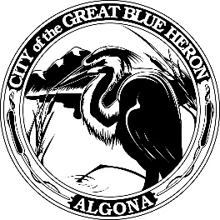 | City Council Regular Meeting
 | Monday, January 22, 2024 at 7:00 PM
 | City Hall
 | Agenda
1. Call to Order
2. Flag Salute
3. Roll Call
4. Presentation
A. 3rd Quarter 2023 Finance Report
5. Approval of Agenda
6. Consent Agenda
A. January 8th, 2024 Council Meeting
B. Audit of Reports
1. Claims #113423 - #113460 = $127,322.62
January 22, 2024
2. Payroll = $107,227.95
January 19, 2024
VOID #113381 & 113398
7. Reports
8. Audience Participation
The City Council encourages public participation during meetings of the City Council and welcomes your comments. This time is set-aside for you to speak to the City Council on any issue. The Council ordinarily takes non-agenda matters under advisement before taking action. You are also invited to comment on action items as they are considered during the meeting. Individual speakers will be limited to three (3) minutes each in addressing the City Council. When addressing the Council, please speak clearly and audibly and state your name and address for the record.
9. Discussion
A. Transportation Improvement Board Grant Agreement
B. EJ Municipal Land Use Planning Agreement
10. New Business
11. Old Business
12. Ordinances & Resolution
A. Resolution 1270-24, Department of Commerce, Local and Community Projects Grant Agreement
13. Next Workshop
14. Adjournment

