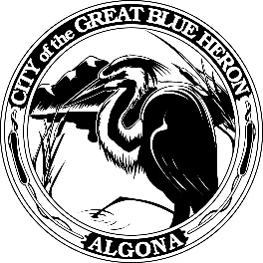 | City Council Regular Meeting
 | Monday, February 12, 2024 at 7:00 PM
 | City Hall
 | Agenda
1. Call to Order
2. Flag Salute
3. Roll Call
4. Presentation
A. Introduction of New Police Officers and Recognition
B. 4th Quarter 2023 Finance Report
5. Approval of Agenda
6. Consent Agenda
A. Minutes
B. Audit of Reports
1. Claims #113461 - #113503 = $242,904.34
February 12, 2024
2. Payroll #61583 - #61586 = $ 94,318.42
February 2, 2024
VOID
7. Reports
8. Audience Participation
The City Council encourages public participation during meetings of the City Council and welcomes your comments. This time is set-aside for you to speak to the City Council on any issue. The Council ordinarily takes non-agenda matters under advisement before taking action. You are also invited to comment on action items as they are considered during the meeting. Individual speakers will be limited to three (3) minutes each in addressing the City Council. When addressing the Council, please speak clearly and audibly and state your name and address for the record.
9. Discussion
A. 2024 Comprehensive Plan - Introduction Chapter, Capital Facilities and Utilities, Natural Environment, and Algona Parks and Rec Elements
10. New Business
11. Old Business
12. Ordinances & Resolution
A. Resolution 1271-24, EJ Municipal Land Use Planning Agreement
B. Resolution 1272-24, Transportation Improvement Board Grant Agreement
13. Next Workshop
14. Adjournment

