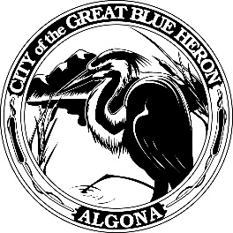 | City Council Regular Meeting
 | Monday, February 26, 2024 at 7:00 PM
 | City Hall
 | Agenda
1. Call to Order
2. Flag Salute
3. Roll Call
4. Presentation
5. Approval of Agenda
6. Consent Agenda
A. Minutes
B. Audit of Reports
1. Claims #113504 - #113531 = $ 87,156.37
February 15 - February 26, 2024
2. Payroll # - # = $ 78,387.90
February 16, 2024
VOID #
7. Reports
8. Audience Participation
The City Council encourages public participation during meetings of the City Council and welcomes your comments. This time is set-aside for you to speak to the City Council on any issue. The Council ordinarily takes non-agenda matters under advisement before taking action. You are also invited to comment on action items as they are considered during the meeting. Individual speakers will be limited to three (3) minutes each in addressing the City Council. When addressing the Council, please speak clearly and audibly and state your name and address for the record.
9. Discussion
A. 2024 Comprehensive Plan - Introduction Chapter, Capital Facilities and Utilities, Natural Environment, and Algona Parks and Rec Elements
B. 2024 Planning Commission Work Plan
10. New Business
11. Old Business
12. Ordinances & Resolution
13. Next Workshop
14. Adjournment

