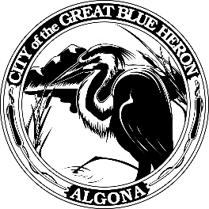 | City Council Workshop Meeting
 | Monday, March 11, 2024 at 6:00 PM
 | City Hall
 | Agenda
1. Call to Order
2. Roll Call
3. Approval of Agenda
4. Presentations
5. Discussion
A. Solid Waste Contract - Technical Assistance with Jeanette Jurgensen
B. Garbage Ordinance
6. Audience Participation
The City Council encourages public participation during meetings of the City Council and welcomes your comments. This time is set-aside for you to speak to the City Council on any issue. The Council ordinarily takes non-agenda matters under advisement before taking action. You are also invited to comment on action items as they are considered during the meeting. Individual speakers will be limited to three (3) minutes each in addressing the City Council. When addressing the Council, please speak clearly and audibly and state your name and address for the record.
7. Adjournment

