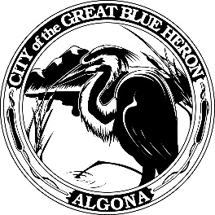 | City Council Regular Meeting
 | Monday, April 22, 2024 at 7:00 PM
 | City Hall
 | Agenda
1. Call to Order
2. Flag Salute
3. Roll Call
4. Presentation
5. Approval of Agenda
6. Consent Agenda
A. Minutes
B. Audit of Reports
1. Claims #1058 - #1088 = $153,593.60
April 15 - April 22, 2024
2. Payroll # - # = $ 80,294.41
April 12, 2024
VOID
7. Reports
8. Audience Participation
The City Council encourages public participation during meetings of the City Council and welcomes your comments. This time is set-aside for you to speak to the City Council on any issue. The Council ordinarily takes non-agenda matters under advisement before taking action. You are also invited to comment on action items as they are considered during the meeting. Individual speakers will be limited to three (3) minutes each in addressing the City Council. When addressing the Council, please speak clearly and audibly and state your name and address for the record.
9. Discussion
A. Resolution 1276-24, Rental Packet Update
B. Resolution 1275-24, Public Works Equipment Surplus List
C. Ordinance 1235-24, 2024 Budget Amendment
D. IAM&AW Collective Bargaining Agreement 2024-2026
10. New Business
11. Old Business
12. Ordinances & Resolution
A. Ordinance 1233-24, Ziply Fiber Franchise Agreement
B. Ordinance 1234-24, Street Racing
13. Next Workshop
14. Executive Session
A. Executive Session
For the purpose of discussing possible property acquisition pursuant to RCW 42.30.110(1)(b).
15. Adjournment

